Florida Academy of Sciences, Inc.
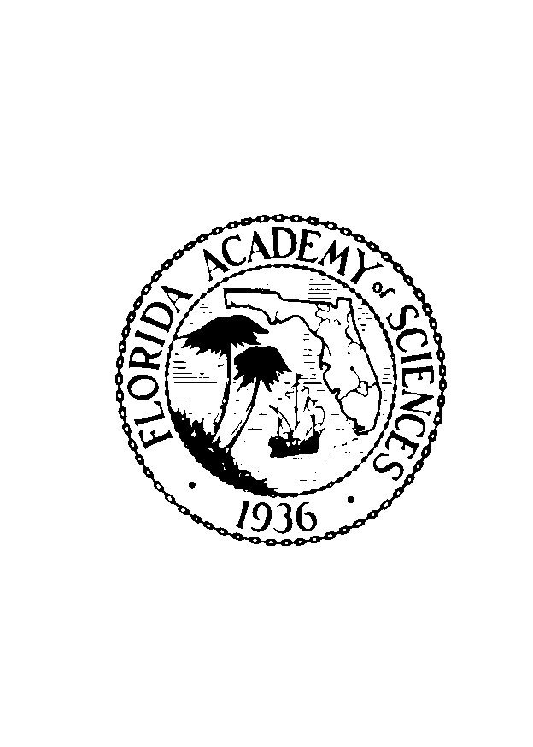

2026 MEDALIST NOMINATION FORM

Nominations are now being accepted for the Florida Academy of Sciences 2026 Medalist. The medal is presented each year at the annual meeting to a resident of the State of Florida who has contributed in an outstanding manner to the promotion of scientific research, to the stimulation of interest in the sciences, or to the diffusion of scientific knowledge. The nominee may be a research scientist, a philanthropist, an educator, a journalist, a science fair coordinator, or a member of industry, government, or other organization and who has met the criteria given above. The candidate need not be a Ph.D. nor be a current member of FAS.

Please send the completed printed form and any supporting PAPER documents to:

Dr. Sesha Srinivasan, Chair
FAS Honors Committee
1821 Altavista Cir.,
Lakeland, FL 33810

OR … email a digital version (pdf format) with supporting digital files to: admin@flacademyofsciences.org

Your nomination form must arrive no later than January 15, 2026. Submission of full curriculum vitae of the nominee is strongly recommended.

NOMINEE

Name;

Affiliation:

Nominee’s contact information:

Mailing address:

Email:

Phone:

NOMINATOR’S STATEMENT

Nominator’s assessment of nominee’s contribution to science in Florida. (See criteria given above.):

ADDITIONAL INFORMATION FOR PROFESSIONAL SCIENTIST NOMINEES

Number of years in scientific endeavor:

Current academic and professional qualifications of nominee:

Number of publications by nominee:
Refereed papers:
Non-refereed papers:
Books authored or edited:
Book chapters:
Other (please specify):

Brief description of the nominee’s most significant scientific activity:

Nominator’s contact information

Name:

Position:

Mailing address:

Email:

Phone:

FAS membership*:

Relationship to nominee:

*FAS membership is NOT required to submit a nomination or for the nominee to be selected to receive the award.

